Research Focus
Volume #, Issue #, Year, p. 13-20
ISSN: 2668-4675
www.researchfocus.org

Photo by Scott Webb on Unsplash

Title (Arial, 16, Bold)

Author 1¹, Author 2², etc (Arial, 12, Bold)
¹ Department, University/Organization, Country (Arial, 12)
2 Department, University/Organization, Country (Arial, 12)

Abstract (Arial, 14, Bold)
Arial 12, Line spacing 1.5, Justified.
Max. 200 words

Keywords (Arial 12, Bold): Max. 5 keywords separated by comma

Introduction (Arial, 14, Bold)
Arial 12, Justified, Line spacing 1.5
Type of citation: APA: (Digital Marketer, 2019).
For citing the bibliography, please use the MS Word tool: References > Select APA from the drop-down menu. Then Insert citation > Add new source > Select the type of refence you cite and fill in the automatic APA fields.

(Concept 1) Title (Arial, 14, Bold)
(Arial 12, Justified, Line spacing 1.5)
Type of citation: APA: (Digital Marketer, 2019).
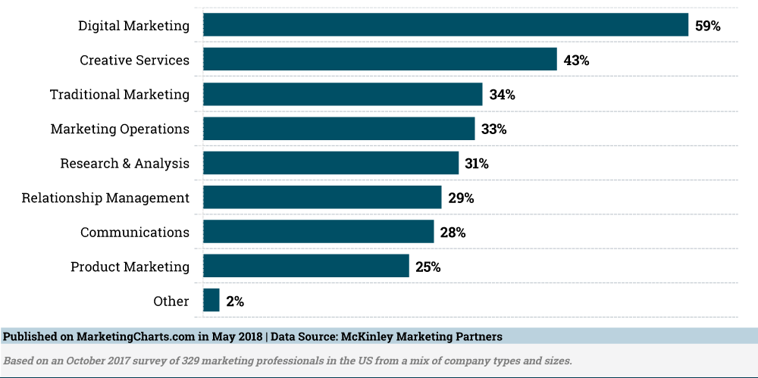

Figure 1. Caption (Arial, 12, Bold, Centered)
(Source: (Marketing Charts, 2018)) (Arial, 12, Centered)

Arial 12, Justified, Line spacing 1.5
Type of citation: APA: (Digital Marketer, 2019).

(Concept 2) Title (Arial, 14, Bold)
Arial 12, Justified, Line spacing 1.5
Type of citation: APA: (Digital Marketer, 2019).

(Concept 2) Title (Arial, 14, Bold)
Arial 12, Justified, Line spacing 1.5
Type of citation: APA: (Digital Marketer, 2019).

Conclusion
Arial 12, Justified, Line spacing 1.5

References
Inserted automatically from MS Word.
Click at the end of the article, then References > Bibliography. Select from the drop-down menu “References’. The list of references will appear automatically. You then need to format the list according to instructions below.

Arial, 11, Justified, Line spacing 1.15

Research Focus. International Open-Access Scientific Journal for Students and Graduates Research

This work is licensed under a Creative Commons Attribution 4.0 International Licence. Articles are free to use, with proper attribution, in educational and other non-commercial settings.

ISSN: 2668-4675

